HOW TO COMPLETE A TIMESHEET:

Please print your NAME clearly. Please print
the place where you worked i.e. name of GP Surgery, Prison, OOH Site etc.
Please only use ONE timesheet per site you have worked at.

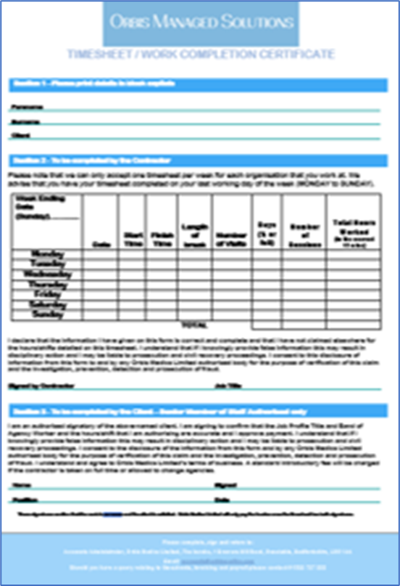

If your contract states sessions please use the number of sessions column.

If your contract terms is per hour, please fill in the hours worked column.

The Orbis Medics working week starts on a
MONDAY and finishes on a SUNDAY. Please only use ONE timesheet per week, per site.

If your contract states days please use the total day’s column.

Timesheet must be signed by yourself and by a lead GP or Practice Manager to ensure payment.
If another member of staff signs it and you have completed additional hours to the contracted agreement we will have to wait for authorisation from the Practice Manager or Lead GP, this may result in a delay on payment.

*Please note that it is your duty to ensure
that the timesheet is completed correctly
and emailed to accounts@orbismedics.com to ensure payment.*

Section 1 - Please print details in block capitals
Forename
Surname
Client

Section 2 - To be completed by the Contractor

Please note that we can only accept one timesheet per week for each organisation that you work at. We advise that you have your timesheet completed on your last working day of the week (MONDAY to SUNDAY).

Week Ending Date (Sunday)……...... | Date | Start Time | Finish Time | Length of break | Number of Visits | Days 1/2 or Full | Number of Sessions | Total Hours Worked (to the nearest 15 mins)
Monday
Tuesday
Wednesday
Thursday
Friday
Saturday
Sunday
 |  |  |  | TOTAL

I declare that the information I have given on this form is correct and complete and that I have not claimed elsewhere for the hours/shifts detailed on this timesheet. I understand that if I knowingly provide false information this may result in disciplinary action and I may be liable to prosecution and civil recovery proceedings. I consent to this disclosure of information from this form to and by any Orbis Managed Solutions Limited authorised body for the purpose of verification of this claim and the investigation, prevention, detection and prosecution of fraud.
Signed by Contractor |  | Job Title Date

Section 3 - To be completed by the Client – Senior Member of Staff Authorised only

I am an authorised signatory of the above-named client. I am signing to confirm that the Job Profile Title and Band of Agency Worker and the hours/shift that I am authorising are accurate and I approve payment. I understand that if I knowingly provide false information this may result in disciplinary action and I may be liable to prosecution and civil recovery proceedings. I consent to the disclosure of the information from this form and by any Orbis Managed Solutions Limited authorised body for the purpose of verification of this claim and the investigation, prevention, detection and prosecution of fraud. I understand and agree to Orbis Managed Solutions Limited’s terms of business. A standard introductory fee will be charged if the contractor is taken on full time or allowed to change agencies.

Name |  | Signed
Position |  | Date
These signatures confirm that the work is complete and the client is satisfied. Orbis Managed Solutions Limited will only pay the invoice once the timesheet has both signatures.

